SWIGGY BANGALORE DELIVERY OUTLET DATA ANALYSIS

# WIREFRAME DOCUMENTATION

A few reports have been made to present the analysis.

DASHBOARD 1:

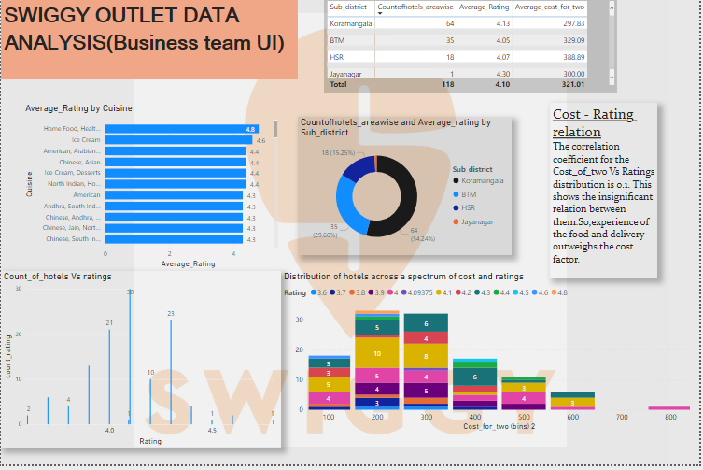

REGION-WISE DISTRIBUTION OF HOTELS:

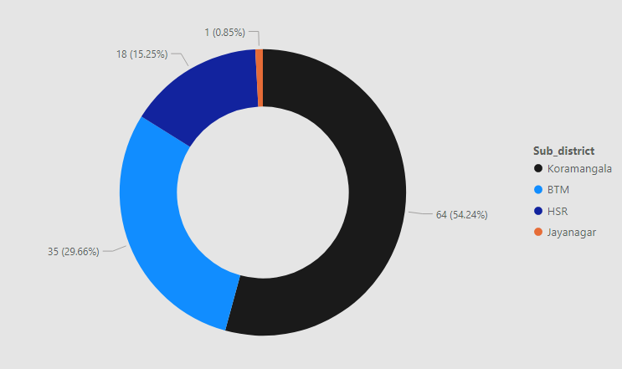

SELECTION OF RESTAURANTS UNDER A SET OF VALUES OF COST AND RATING:

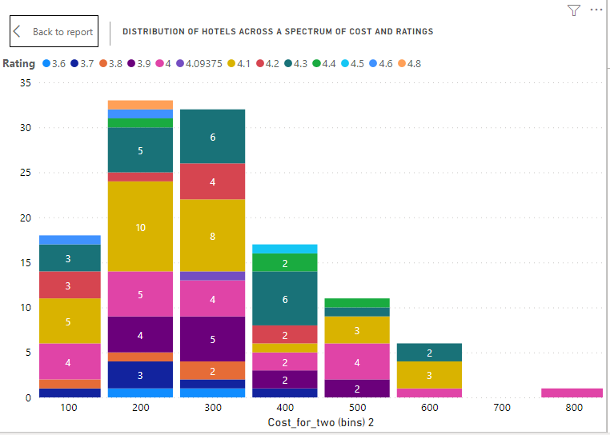

CUISINE Vs RATING:

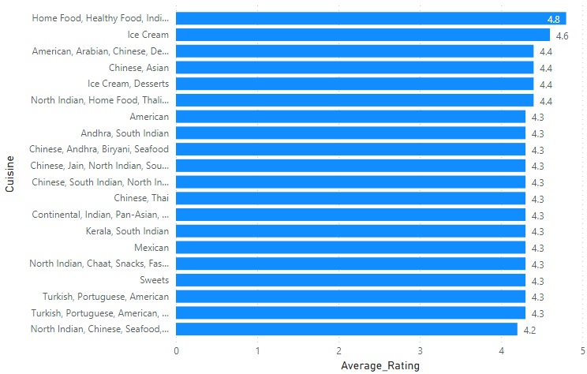

NUMBER OF HOTELS Vs RATINGS

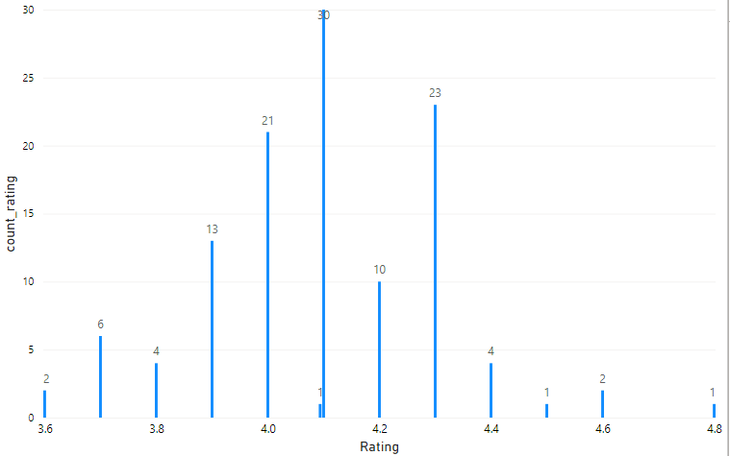

DASHBOARD 2:

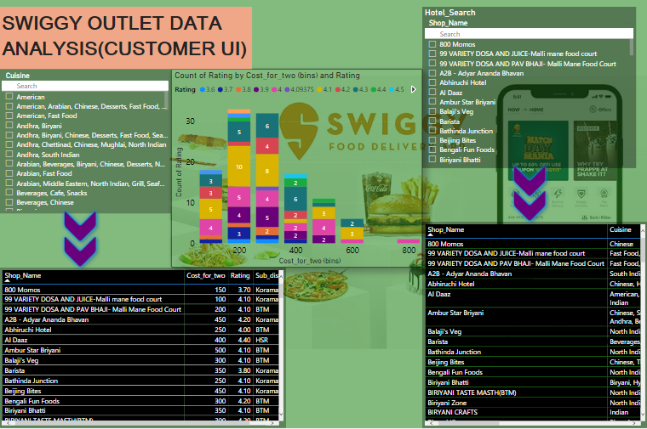

RESTAURANT NAME BASED RESTAURANT SEARCH SLICER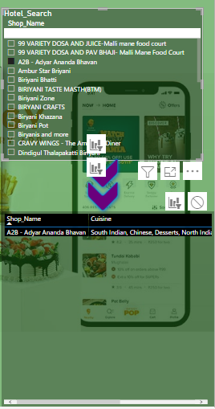

CUISINE SEARCH BASED RESTAURANT SELECTION SLICER:

